Hudson Valley Show Jumping
Sponsorship Opportunities

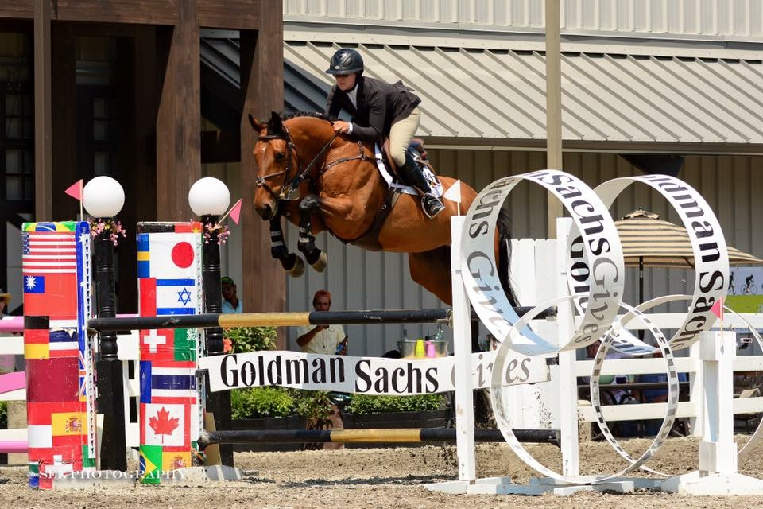
Hudson Valley Show Jumping 2017 Title Sponsor: $15,000 [ ✔] 
- Naming rights to all 2016 Hudson Valley Show Jumping Events
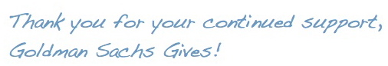
- Sponsor name to appear on all official HVSJ Communications and Awards.
- Full page ad in Show Program
- Logo on cover of Show Program
- Custom Show jump at all 2016 Hudson Valley Show Jumping Events
- Award presentation opportunities at all events
- Recognition & link on website, emails and social media and public address announcements
- 2 Banners to be displayed in competition and schooling rings

Fall Classic Mini Prix Sponsor: $6,000 [ ]
- Sponsorship and Naming rights of the $10,000 Fall Classic Mini Prix
- Custom Show Jump
- Award presentation opportunity for the Fall Classic Mini Prix (Sunday, Oct. 8, 2017)
- Sponsor name to appear on awards for Fall Classic Mini Prix
- Full page ad in Show Program
- Recognition & link on website, emails and social media and public address announcements
- Banner to be displayed in competition ring (Opportunity to display additional banners, supplied by sponsor, throughout show grounds)
- Vendor space and opportunity to provide product samples at HVSJ Fall Classic

Summer Classic Mini Prix Sponsor: $3,000 [ ]
- Sponsorship and Naming rights of the Summer Classic Mini Prix
- Show Jump signage
- Award presentation opportunity for the Summer Classic Mini Prix (Sunday, Jun. 25, 2017)
- Sponsor name to appear on awards for Summer Classic Mini Prix
- Full page ad in Show Program
- Recognition & link on website, emails and social media and public address announcements
- Banner to be displayed in competition ring (Opportunity to display additional banners, supplied by sponsor, throughout show grounds)
- Vendor space and opportunity to provide product samples at HVSJ Summer Classic

Spring Classic Mini Prix Sponsor: $2,500 [   ]
- Sponsorship and Naming rights of the Spring Classic Mini Prix
- Show Jump signage
- Award presentation opportunity for the Spring Classic Mini Prix (Sunday, April 23, 2017)
- Sponsor name to appear on awards for Spring Classic Mini Prix
- Full page ad in Show Program
- Recognition & link on website, emails and social media and public address announcements
- Banner to be displayed in competition ring (Opportunity to display additional banners, supplied by sponsor, throughout show grounds)
- Vendor space and opportunity to provide product samples at HVSJ Spring Classic

2017 Blue Ribbon Sponsor $2,000 [ ]
- Sponsorship of all 2017 Child/Adult Jumper Classics at all Hudson Valley Show Jumping Events
- Custom Show Jump at all 2017 Hudson Valley Show Jumping Events
- Award Presentation opportunity at all 2017 Hudson Valley Show Jumping Events
- Full page ad in Show Program
- Recognition & link on website, emails and social media and public address announcements
- Banner to be displayed in competition ring (Opportunity to display additional banners, supplied by sponsor, throughout show grounds)
- Vendor space and opportunity to provide product samples at shows

Rider Bonus Sponsor: $2,000
- Sponsorship of the $1,500 Hudson Valley Show Jumping Rider Bonus
- Annual Show Jump signage
- Award presentation opportunity for the 2017 Rider Bonus (Sunday, October 8, 2017)
- Full page ad in Show Program
- Recognition & link on website, emails and social media and public address announcements
- Banner to be displayed in competition ring (Opportunity to display additional banners, supplied by sponsor, throughout show grounds)

Exhibitor Party Sponsor: $1,250 Each Show: Spring [    ]  Summer [ ] Fall [ ] Holiday [ ]
- The exhibitor party is a popular and well-attended event; this is a great opportunity for brand recognition among competitors, trainers, owners, etc.
- This sponsorship underwrites the Hudson Valley Show Jumping exhibitor parties
- Sponsor’s name and logo will be prominently displayed throughout parties on signs, paper goods, etc.
- Full page ad in Show Program
- Recognition & link on website, emails and social media and public address announcements
- Banner to be displayed in competition ring. (Additional banners, supplied by sponsor, may be displayed throughout show grounds)
- Vendor space and opportunity to provide product samples at all shows

Jump Sponsor (Limited number): Individual per show $1,000 ~ Spring [   ] Summer [ ] Fall [ ] Holiday [ ] or Annual $3,000 [ ]
- Show Jump signage
- Full page ad in Show Program
- Recognition & link on website, emails and social media and public address announcements

Platinum Sponsor: Annual $1,500 or Individually per show $500 ~ Spring [   ] Summer [ ] Fall [ ] Holiday [ ]
- Award presentation opportunity at the horseshows
- Banner to be displayed in competition ring (Opportunity to display additional banners, supplied by sponsor, throughout show grounds)
- Full page ad in Show Program
- Vendor space
- Recognition & link on website, emails and social media and public address announcements

Family Day Sponsor: Summer Classic $1,500 [ ] Fall Classic $1,500 [ ]
- This sponsorship underwrites the popular Family Day Festivities: Pony rides, Face painting, Pumpkin decorating, Petting zoo, etc.
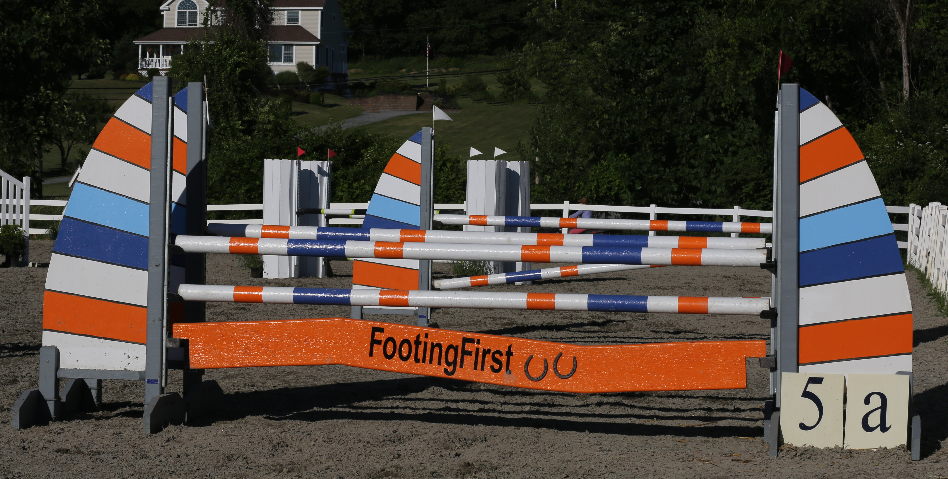
- Full page ad in Show Program
- Signage throughout the Family Day tent and competition areas
- Recognition & link on website, emails and social media and public address announcements
- Vendor space and opportunity to provide product samples during the events

Gambler’s Choice (Multiple available):[ ]
- Custom Sponsorship: If you have goods or a specific service that your business would like to share, a custom sponsorship package is available.
- Example: Official Arena footing & equipment sponsor, Tack sponsor, Saddle pads, Coolers, etc.
- Banner to be displayed in competition ring (Opportunity to display additional banners, supplied by sponsor, throughout show grounds)
- ½ page ad in Show Program
- Recognition & link on website, emails and social media and public address announcements
- Vendor space and opportunity to provide product samples at shows
- Call with questions or for ideas

Back Number Sponsor: $750 [✔] 
- Your name or logo on the exhibitor back number that riders wear and take home. Many riders keep their numbers as collectible mementos.
- 1/2 page ad in Show Program
- Recognition & link on website, emails and social media and public address announcements
- Opportunity to display additional banners, supplied by sponsor, throughout show grounds

Ring Banner Sponsor: Annual $750 or Individually per show $300~ Spring [ ]  Summer [ ] Fall [ ] Holiday [ ]
- Company banner displayed in competition ring (Opportunity to display additional banners, supplied by sponsor, throughout show grounds)
- Recognition & link on website, emails and social media and public address announcements

Show Program Ad
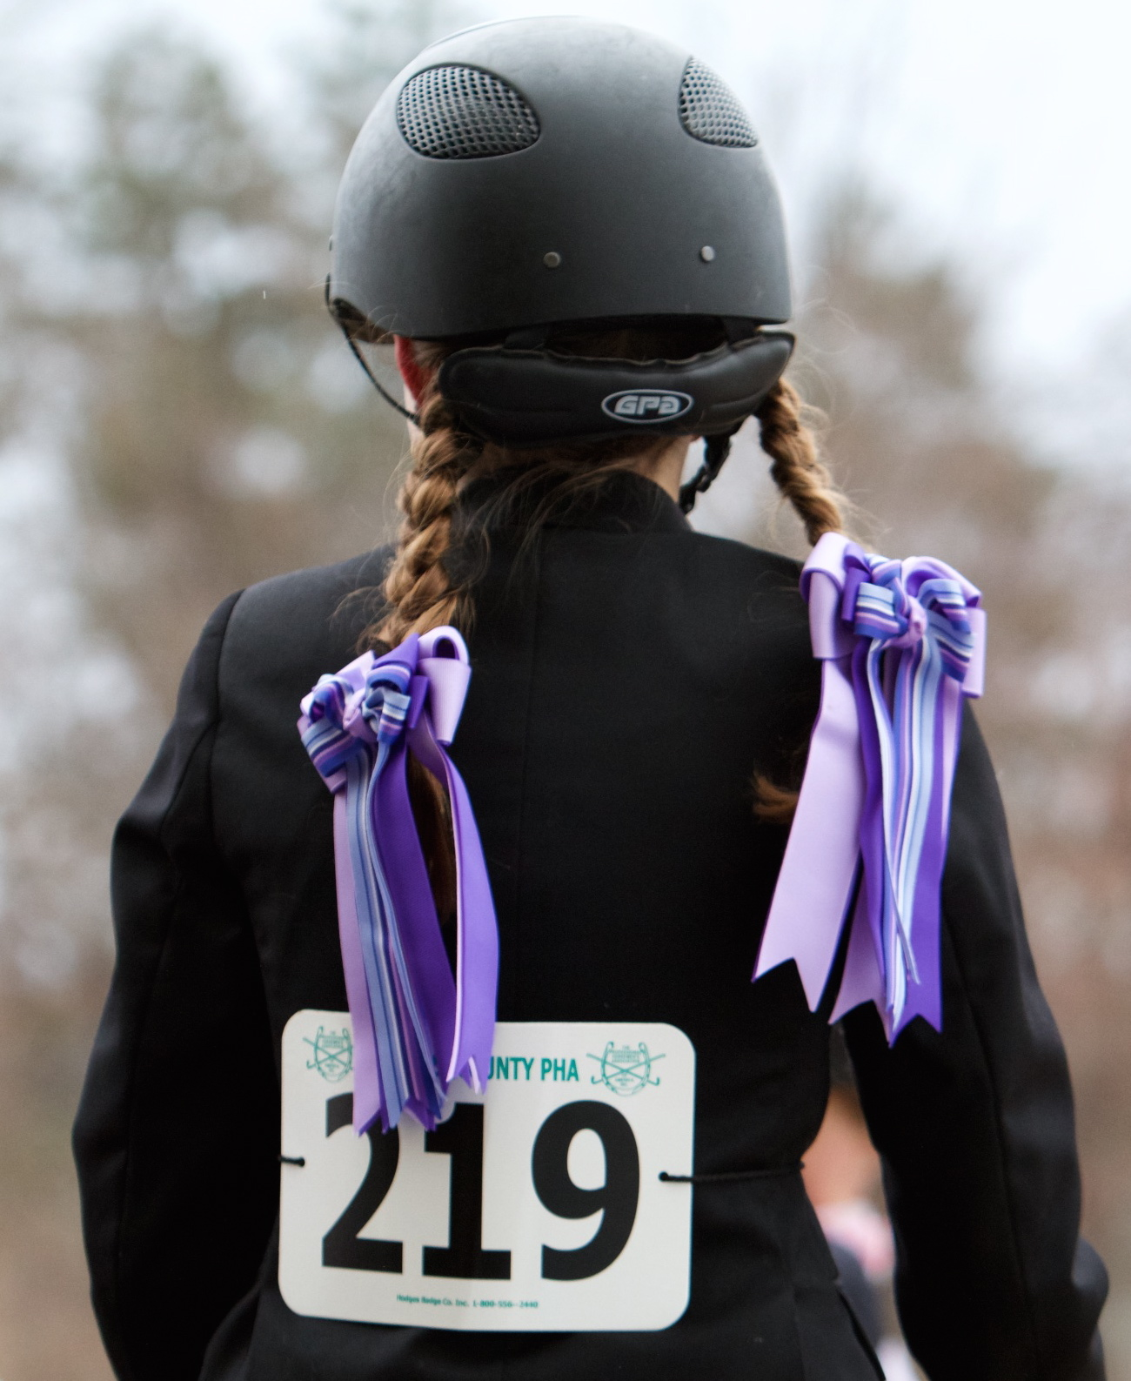
- Inside Front Cover: Annual, full page / full color $750 [ ]
- Inside Back Cover: Annual, full page /full color $750 [ ]
- Full page: Annual $400 [ ]
- ½ page - Annual $250 [ ]

